38.73: a) The photon’s energy change 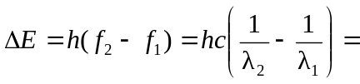
which is a loss for the photon, but which is a gain for the electron. So, the kinetic energy of the electron is 
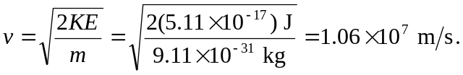
b) If all the energy of the electron is lost in the emission of a photon, then
